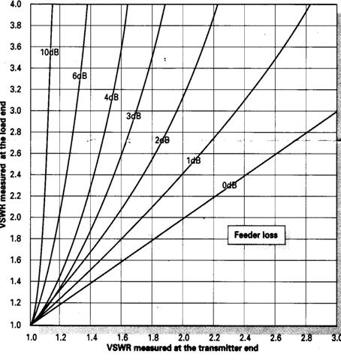
Your SWR meter may not tell the truth.
This is rather an old subject but the illustrations here from an old Practical Wireless should be very clear for even the non-technical.
The curve- and axes values illustrate that if your feeder is not ideal, you will have losses and your SWR meter down in the shack will show an optimistic SWR lower than the real SWR at the antenna.
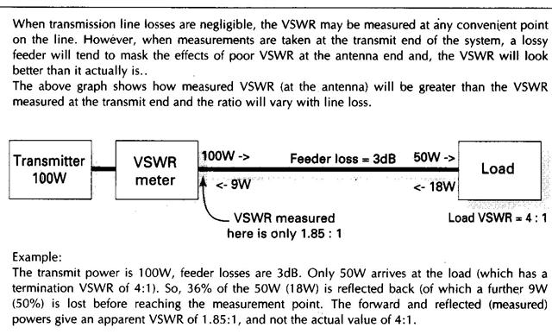
Strive for zero loss by using the shortest and / or low loss feeder cable. Note that the SWR values are only the same at the source and load when loss=0dB

